

ABC Awards Level 2
Motor Vehicle Studies

Underpinning Knowledge Evidence Record

Y/601/3740 Knowledge of Light Vehicle Transmission and Driveline Units and Components

Learners Name
ABC Awards Registration Number
Centre Name
Assessor 1 Name
Assessor 2 Name

DECLARATION OF AUTHENTICITY

This declaration must be completed and signed by the learner and countersigned by the tutor / assessor and covers all evidence submitted for moderation.

Learner Name
Unique Learner Number (ULN) |  | ABC  Learner Reg. ID
Qualification Title
Centre Name

Learner statement of authenticity

Before signing please read the guidance below.

I confirm, that the attached assignment / portfolio is all my own work and does not include any work completed by anyone other than myself. I have completed the assignment / portfolio in accordance with ABC Awards’ instructions and within the time limits set by my centre.

Signature |  | Date

Centre confirmation of authenticity

On behalf of …………………………………….(insert centre name), I confirm that the above mentioned learner, to the best of my knowledge, is the sole author of the completed assignment / portfolio attached, and the assessments have been completed under the required conditions.

Signed |  | Date
Name
Title

Guidance for Learners

You have been asked to sign this Declaration of Authenticity and place it at the front of your portfolio or course work assessment. It confirms that the work you have submitted for assessment is your own and that you have not copied it from someone else or allowed another learner to copy it from you.

When preparing any course work it is good practice to undertake research using information from published sources. If you quote directly from these sources then this must be indicated in your work by using quotation marks and referencing the document from which the quotation was taken. You must then comment in your own words on any ideas expressed.

Assessors, internal verifiers and ABC Awards’ external moderators and verifiers are subject specialists who can spot the use of published materials that may be passed as your own words or ideas.
If you do copy words from a published source and do not indicate their reference you will be committing plagiarism. This is considered a form of cheating and may result in your assessment being declared void.
Contents

Task No | Title | Assessment Criteria
1 | Clutch systems | 1.1, 1.2, 1.3, 1.4, 1.5, 4.2, 4.4
2 | Manual gearboxes | 2.1, 2.2, 2.3, 2.4, 2.5, 4.2, 4.4
3 | Driveline | 3.1, 3.2, 3.3, 3.4, 3.5, 4.2, 4.4
4 | Removing and replacing transmission and driveline systems | 4.1, 4.3

Task 1 – Clutch systems | Assessment Criteria 1.1, 1.2, 1.3, 1.4, 1.5, 4.2, 4.4

Label this light vehicle clutch assembly
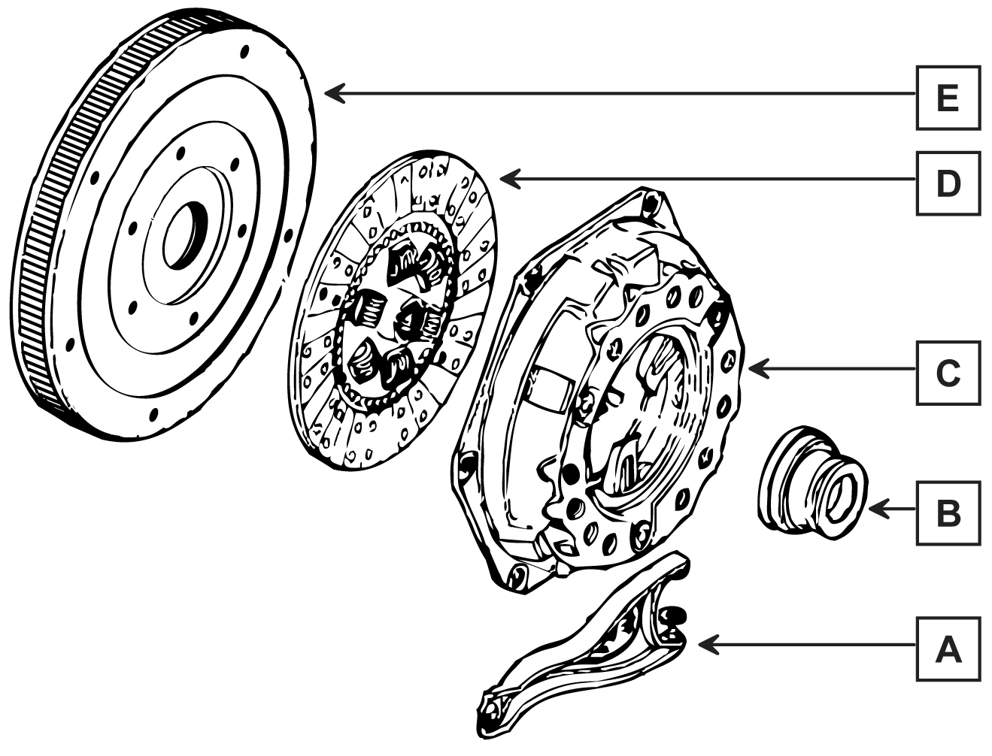
A
B
C
D
E

Identify and explain the operation of these light vehicle clutch systems and compare their construction
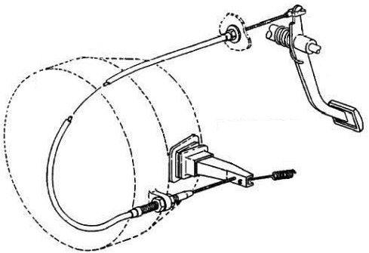
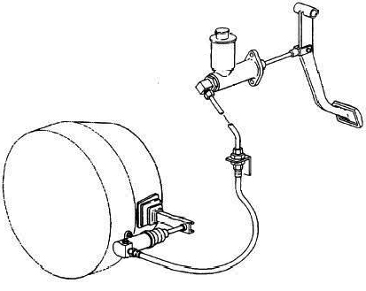

Describe 2 different methods to test the operation of hydraulic and cable operated clutch systems and components and the purpose of each test. Include how you would compare against manufacturer specification
System | Test method 1 (Clutch Slip) | Test method 2 (Clutch Drag)
Hydraulic
Cable
Clutch assembly

Give at least 3 examples of common clutch system faults and common causes for each
System | Fault 1 | Fault 2 | Fault 3
Hydraulic
Cable
Clutch assembly

Explain the following key engineering principles relating to clutch systems
Principle | Explanation
Principles of friction
Principle of levers
Transmission of torque

Task 2 – Manual gearboxes | Assessment Criteria 2.1, 2.2, 2.3, 2.4, 2.5, 4.2, 4.4

Identify the labelled light vehicle manual gearbox assembly components below
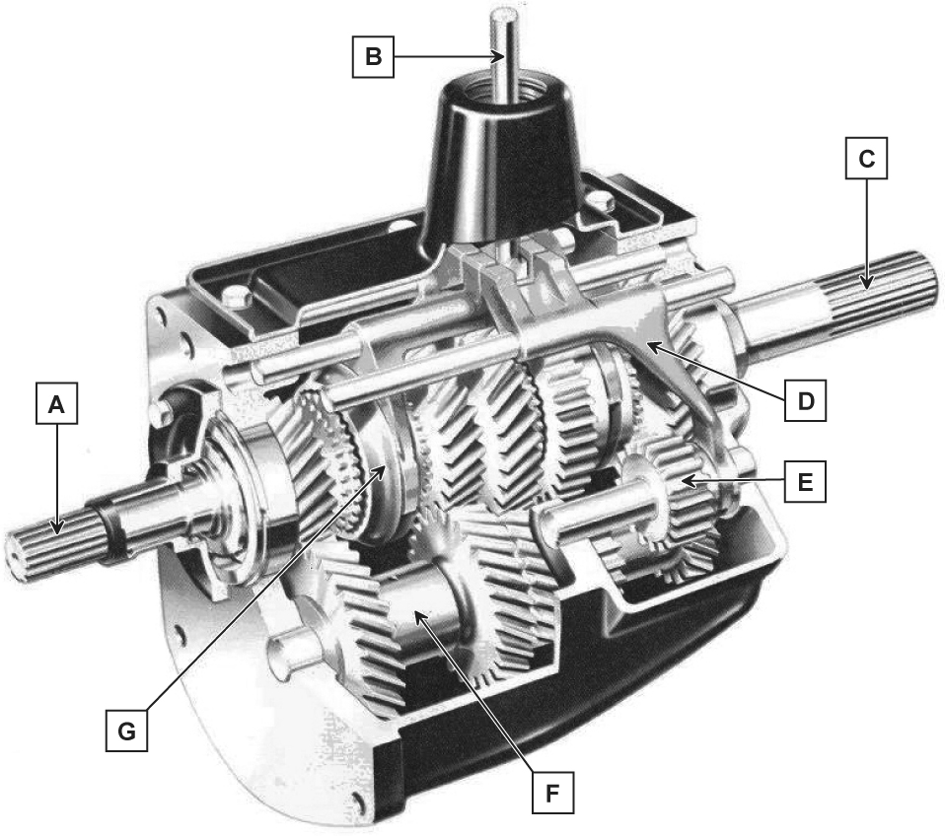
A
B
C
D
E
F
G

Draw a basic layout of the following types of gearbox and compare each system against each other on construction and operation
Front wheel drive (FWD) | Explanation of Construction and Operation
Rear wheel drive (RWD) | Explanation of Construction and Operation
Four wheel drive (4WD) | Explanation of Construction and Operation

Describe 2 different methods to test the operation of the following gearboxes and the purpose of each test. Include how you would compare against manufacturer specification
System | Test method 1 | Test method 2
Front wheel drive (FWD)
Rear wheel drive (RWD)
Four wheel drive (4WD)

Give at least 3 examples of common gearbox faults and common causes for each
Gearbox | Fault 1 | Fault 2 | Fault 3
Front wheel drive (FWD)
Rear wheel drive (RWD)
Four wheel drive (4WD)

Explain the following key engineering principles relating to clutch systems
Principle | Explanation
Gear ratio
Torque multiplication

Task 3 – Driveline | Assessment Criteria 3.1, 3.2, 3.3, 3.4, 3.5, 4.2, 4.4

Identify the labelled light vehicle final drive unit components in the table below
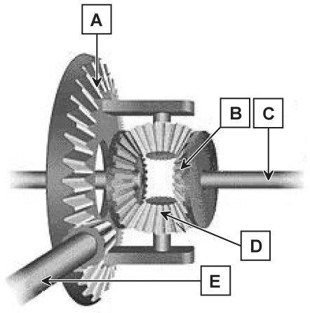

A
B
C
D
E

From the images shown compare each system against each other in terms of construction and operation
Drive Shaft | Explanation of Construction and Operation
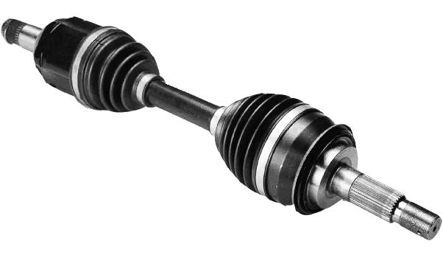
Propellor Shaft | Explanation of Construction and Operation
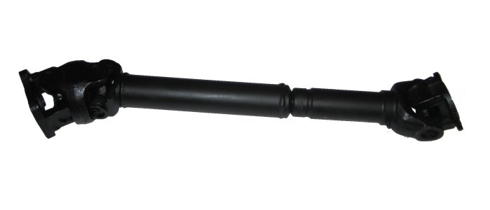
Differential | Explanation of Construction and Operation
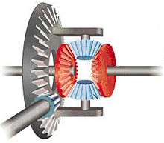

Describe 2 different methods to test the operation of the following driveline systems and the purpose of each test. Include how you would compare against manufacturer specification
System | Test method 1 | Test method 2
Drive shaft
Propellor shaft
Final drive

Give at least 3 examples of common driveline faults and common causes for each
System | Fault 1 | Fault 2 | Fault 3
Drive shaft
Propellor shaft
Final drive

Explain the following key engineering principles relating to clutch systems
Principle | Explanation
Final drive and overall gear ratios
Simple stresses

Task 4 – Removing and replacing Transmission and driveline systems | Assessment Criteria 4.1, 4.3

Describe safe removal and replacement procedures of the following transmission and driveline systems, units and components
Clutch system

Gearbox assembly
Driveline assembly
Explain how to evaluate the performance of replacement units against vehicle specification

Unless otherwise stated e.g. for some entry level qualifications, learners can work together but should identify sections which are their own work.

